Alex Becker

Lab Goal: For this lab, you must determine what the jeroo needs to do in order to complete the requirements of the lab. You must also decide how many flowers the jeroo must start with to clear the nets.

Lab Description: This lab requires you to use if statements along with loops.You must have the jeroo start at the beggining of the maze and spiral to the center. You must also clear the nets that are in the path of the spiral. The jeroo should spiral to the center and face east when it stops. You can only use one method.

Starting Screen:

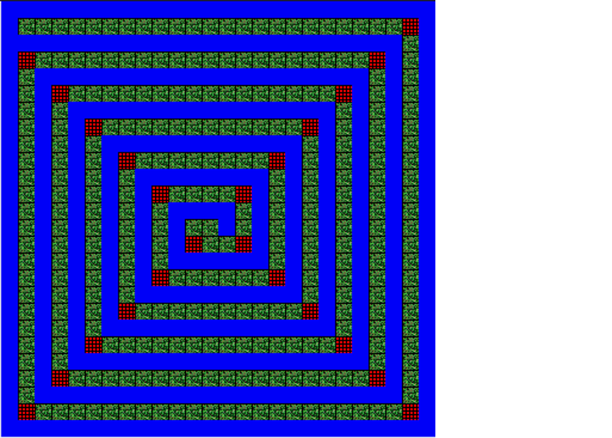Files Needed:

jerooProjectTemplate.jsc

jerooProjectTemplate.jev

Ending Screen: jerooProjectSolution.jsc

